CS691 – Computer Science, Spring 2022

Pace University



SYSTEM TEST PLAN

QuickFeed

Authors: Sathvik,Akshay,Rohith,Sayali,Sagarika,Shubham

Project Manager: Lakshmi Bhavani Cheekala

Date: 04/22/2022

**Table of Contents**

1. INTRODUCTION 3
2. TESTING SCOPE 3
3. TESTING OBJECTIVES 3

3.1 Features to be Tested 3

3.2 Features not to be Tested 4

1. TEST PROCESS DEFINITION 5

4.1 Test Process Phases and Tasks 5

4.2 Deliverables 6

1. APPROACH TO SYSTEM TESTING 7

5.1 Approach to Functional Testing 7

5.2 Approach to Non- Functional Testing7

1. ENTRY/EXIT CRITERIA 8

6.1 Entry Criteria 8

6.2 Exit Criteria 8

1. ENVIRONMENTAL NEEDS 9
2. ROLES AND RESPONSIBILITIES 10
3. TEST CYCLES AND SCHEDULE 11
4. RISKS AND CONTINGENCIES 11

# 1.INTRODUCTION

This document describes the System Test Plan that provides a common understanding among the “QuickFeed” project stakeholders on the scope, objectives, and approach to performing the system testing. Also, the document explains the features to be tested, testing entry/exit criteria, resource and responsibilities, and testing schedule.

# 2.TESTING SCOPE

The testing scope includes two perspectives - the functional scope and technical scope.

The functional scope includes the following modules of the “QuickFeed” system:

Authenticate the User,Summarize the Details,Register the Service Provider.

The technical scope includes the following architectural components:

* Web browser
* Application server
* Database server

# 3.TESTING OBJECTIVES

The primary focus of this System Test Plan is functional testing with the objective to evaluate the system implementation stability. The non-functional testing requires some special tooling to monitor performance characteristics, which is not available on this project.

The basis for developing functional tests and evaluating the system functionality includes the following sources:

* Business Requirements Document (BRD)
* User Stories (functional requirements)
* Requirements Composition Table (supplementary requirements)

## 3.1.Features to be Tested

This section lists all core features that will be tested grouped by the application modules below.

User Registration/ Login

* create an User Account

– To test whether a user is able to create the account.

* create Service/Goods provider Account

– To test whether service/goods is able to create the account.

* Login

– To test whether the customer and Service/Goods provider is able to log in to the accounts.

* User Authentication

– To test whether a user is able to authenticate his account.

* ServiceAuthentication

– To test whether a service provider is able to authenticate his account.

User Account Management

* Modify the Account details

– To test whether the user is able to modify the account details.

User Experience

* View the summarized details of the account

– To test whether the service/goods provider is able to view the summarized details of the account.

Besides the core features in the scope of testing, the function testing also will cover crosscutting concerns that are applicable to the context of the individual core features (refer to the RCT).

## 

## 3.2.Non-Functional Features to be Tested

The System Test includes the following objectives to test non-functional requirements:

* **Portability testing** is used to validate that both browsers, MS Internet Explorer and Google Chrome, can be equally used by customers;
* **Extreme layout testing** validates that changing Windows display settings, e.g. Hi and Low resolutions and small and large fonts, does not affect the system’s usability;

## Features not to be Tested

As mentioned above, system performance will not be tested for the lack of required tools. Also, usability and security will not be tested as well.

# 

# 

# 4.TEST PROCESS DEFINITION

## 4.1 Test Process Phases and Tasks

The test process consists of five phases, which include test planning, design, preparation, execution, and reporting. Each phase has a few tasks as defined below:

* Test Planning
  + Define scope and objectives of testing
  + Define roles and responsibilities
  + Define testing approach
* Test Design
  + Identify test ideas, define an approach to designing test cases
  + Develop test case specifications
  + Measure test coverage
  + Determine requirements for test data
* Test Preparation
  + Setup a test environment
  + Provision test data
  + Install the software in the test environment
* Test Execution
  + Execute all test cases
  + Find and report software defects
  + Evaluate the system stability
  + Validate all target features
* Test Reporting
  + Summarize and report the test execution results
  + Report defect metrics
  + Evaluate the test exit criteria
  + Create a test completion report, submit for stakeholder approval
  + Obtain stakeholder signoff on system testing

## 

## 

## 

## 4.2 Deliverables

On this project, the test process deliverables include:

| Process Phase | Tasks | Deliverables |
| --- | --- | --- |
| Test Planning | * Define the scope, objectives, and approach to system testing | * System Test Plan document |
| Test Design | * Detail the approach to system testing * Specify required test data * Design test-case specifications * Setup a test management system | * Test Design Specification * Test-Case Specifications * qTest test management platform |
| Test Execution | * Test the system and find and report defects | * Defect reports reported in the defect tracking system * The system has been completely tested * Test Summary Report produced and approved |
| Test Reporting | * Produce defect metrics * Report test execution progress * Produce a test completion report | * Test Summary Report * Defect metrics * Test execution status reports |

# 

# 

# 

# 

# 

# 

# 5.APPROACH TO SYSTEM TESTING

## 5.1.Approach to Functional Testing

The System Test will be performed based on the black-box techniques. This means, first, that the external functional specifications or business rules will be used as a primary source to design test conditions. Secondly, testing will be executed from the user perspective, i.e., considering the system as a black box and entering input data and evaluating results via the user interface.

The system features identified above can be classified by the following types of business logic – GUI, Field Edits, Field Dependencies, and General Business Rules. Each type can have its own test logic that can be reused across the system. Test conditions can be designed using conventional techniques, such as boundary analysis, equivalence partitioning, decision tables, etc. The detailed test logic for each pattern of business rules will be described in the test design specification.

## 5.2 Approach to Non-Functional Testing

All non-functional test objectives specified above can be tested using the black-box approach, i.e. from the user perspective. The volume test should be performed for a complete production scenario that covers the allocation steps, sending emails, and uploading and committing results. The portability and extreme layout tests should cover all functions (menu options) of the system and validate that each function works under the specified test conditions.

# 

# 

# 

# 

# 

# 6.ENTRY/EXIT CRITERIA

This section defines both Entry and Exit Criteria for test execution and is intended to establish a common understanding about the conditions when the test execution can start and when it can stop.

## 6.1.Entry Criteria

The test Entry Criteria is used to formally evaluate the conditions necessary to begin test execution, it includes the following conditions and include the following items:

* The application build is produced and deployed to the test environment
* The system test plan is produced and approved
* The test environment is ready for testing
* Test Designs and test case specifications are completed

## 6.2.Exit Criteria

The test Exit Criteria is used to evaluate the conditions necessary to conclude that testers can stop test execution and the system is ready for the final user acceptance testing and include the following items:

* Zero defects of Critical and High-severity remain open
* Open defects of Medium and Low severity have known work-arounds
* Test Summary report is produced and communicated with the stakeholders.

# 

# 

# 

# 

# 

# 

# 

# 7.ENVIRONMENTAL NEEDS

The Test Environment should be available to start test execution. It includes a laptop with virtual machine running the web server and database, and internet browsers (Chrome, Firefox, Internet Explorer and Safari) to access the application. The architecture of the test environment is shown below.

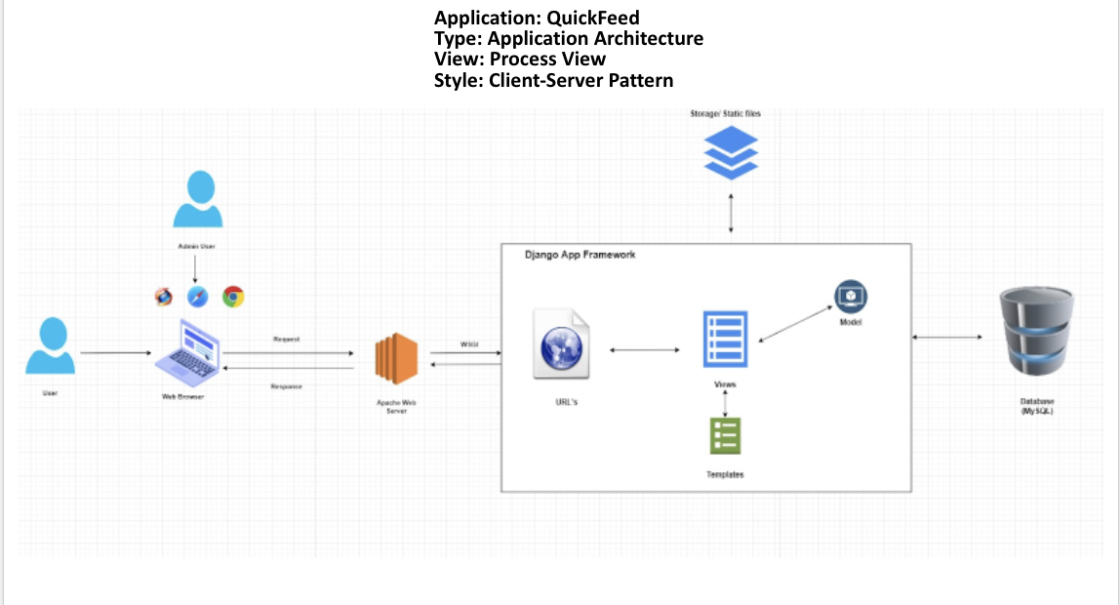

# 

# 

# 

# 

# 

# 

# 8.ROLES AND RESPONSIBILITIES

The project team has eight members that are assigned various project roles including Project Manager, Product Owner, Lead Business Analyst, Lead Developer, DBA, Lead QA Analyst,Tester. Their responsibilities are defined in the table below.

| **Project Role** | **Role Responsibilities** |
| --- | --- |
| Project Manager | Responsible for the overall project timelines, review and approval of the System Test Plan, escalation of issues.Manage the Test Environment Preparation. |
| Lead QA Analyst | Responsible for developing test cases, overseeing test execution, conducting defect review calls, providing test execution metrics and reports. |
| Product Owner | Contributing to the Test Planning and Test case specification and reviewing the Test Results |
| Lead Business Analyst | Contributing to the Test Planning and Test case specification and reviewing the Test Results |
| Lead Developer | Responsible for producing a working software build, build migration to the QA environment, communicating release notes, investigating and fixing software defects.Assisting the Lead QA Analyst throughout the testing . |
| DBA | Assisting the Lead QA Analyst throughout the testing . |
| Testers | Responsible for developing and executing test cases, reporting defects and re-testing defect fixes |

# 

# 

# 

# 9.TEST CYCLES AND SCHEDULE

The system test execution will be conducted as three test cycles that are aligned with three application modules as follows:

Cycle 1. User and Service Provider Registration/login

* Focuses on testing the registration, login and authentication features.

Cycle 2. User Account Management

* Focuses on testing the modify the account feature.

Cycle 3. User Experience

* Focuses on testing, view the summarized account details feature.

# 

# 10.RISKS AND CONTINGENCIES

This section highlights a few potential risks and contingencies that may happen during the system testing.

* Limited testing resources may result in a delay.
* Changes to the implementation scope or existing functional requirements
* A large number of defects require a longer time to fix defects and complete testing.
* Instability of the test environment can impact the test execution schedule.